Insert Your Logo Here

Online Marketing Proposal
Prepared for:
Prepared by:
Date

Executive Summary

Background
Information about the business, why they approached you. Keep to no more than 3 paragraphs.

Key Issues
The Key Issues Facing The Business - maximum 3 Key Issues

Objectives
The Objectives relate directly to the Key Issues - these MUST be measurable. List maximum of Three Objectives. This is what YOU are being measured on.

Strategies
Strategies | Benefits
A Strategy Is The Blueprint. The Overall Map. Depending on the brief will depend on the number of strategies. Likely to be three to five. | What is the Benefit to the Business to implement this Strategy? Include that here.

Action Plan

First Action
  - Action Plan is the specific Actions you recommend they take. So where Strategy is the blue print. Action is the exactly what and how.
  - An analogy for Strategy vs Plan is that your Strategy is to Travel from the USA to Australia. The Plan is to leave in September, take a plane to Hawaii, spend a week on the beach there, and then get on a cruise and sail to Australia. The Plan is exactly what your path will be, how you go, when you go etc.
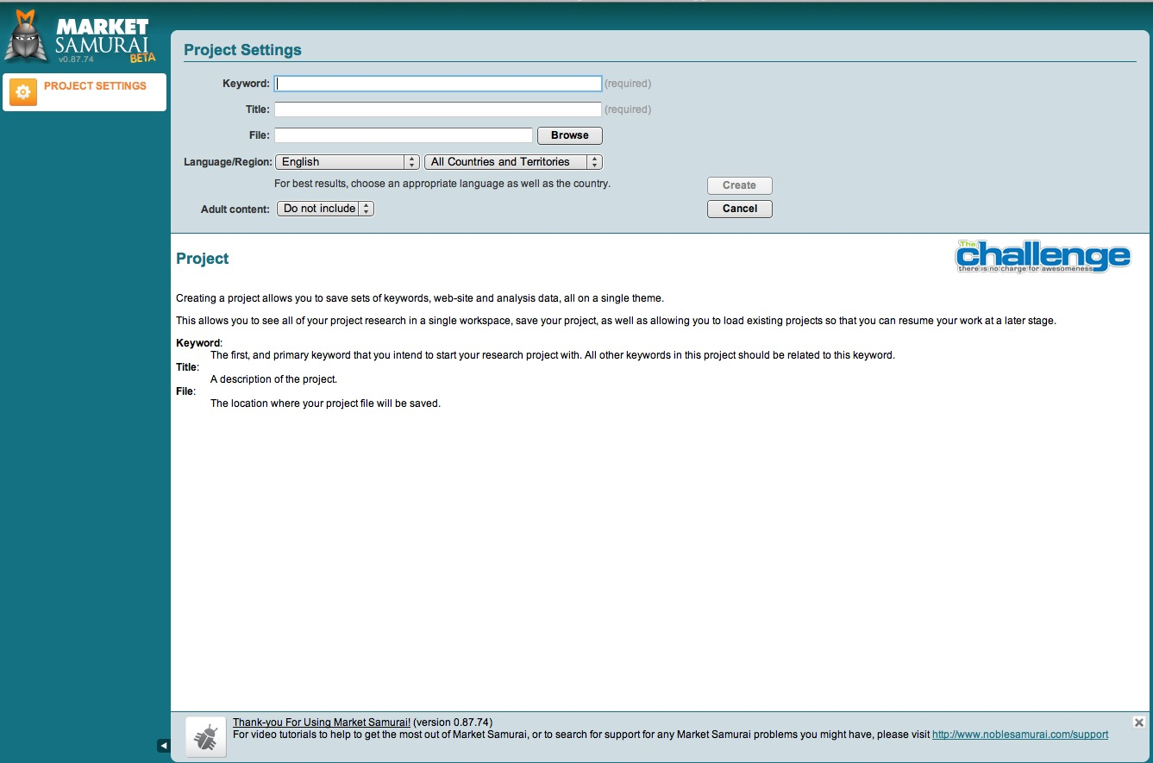
  - Generally there will be the same number of Actionable steps as there are strategies. For example you may have a strategy that involves Keyword Research. Then you have that as your first step in the Action Plan. If the next strategy is to create an Optimized Brand Website. That would be the 2nd point in the Action Plan.
  - Include a visual representative of what you are going to do for each Action Step, relate it to their business category if you can. See example below.

Pricing - USD or currency relevant to your country

With Pricing. Put the rate card fees of each element here without any discounting.
On another page (see next page) package it up and include discounts. Show rate card fee and then the discount. e.g. $1000 $500
Action | Price

Recommended Package - USD or Currency relevant to your country.

Depending on the size of the brief, you may decide to offer your solutions in stages. Or you may split it out in stages to show upfront fees, like for a website, and then monthly fees for things like SEO services and reputation management.
Stage One
Total
Stage Two
Total

Payment Terms

Recommended you approach Payment terms as the following:

First 50% of quoted figure to be paid prior to any work beginning on this project. Balance due within 7 days of project completion.

Ongoing monthly services as per Stage Two, requires full payment in advance of services being rendered.

Contact Information
You are welcome to contact me at any time during usual business hours, Monday-Friday 9-5pm on:

Your Name
email: Your Email
mobile: Your Phone Number

