Kindle Boot Camp/ Look In Class Workbook
Class 1 – Big Picture and Research

Copyright 2013
Jay Boyer
James J Jones
Matt Rhodes
John S Rhodes

Instructions: After each class you will be provided with a workbook containing your homework assignments and instructions. Please print out the workbook after each class and complete the homework assignment. You may find it helpful to get a 3-ring binder from Office Depot or Staples and put all your workbooks in the binder to keep everything organized.

Index

Class 1 – Big Picture and Research

Class 2 – Research Part 2 and Tools

Class 3 – Writing and Content

Class 4 – Images and Covers

Class 5 – Outsourcing

Class 6 – Publish and Launch

Class 7 – Rank and Promote

Class 8 – Kindle Systems

Class 1 – Big Picture and Research

Assignments:

- Watch the replay from this class. It’s available in the member’s area.

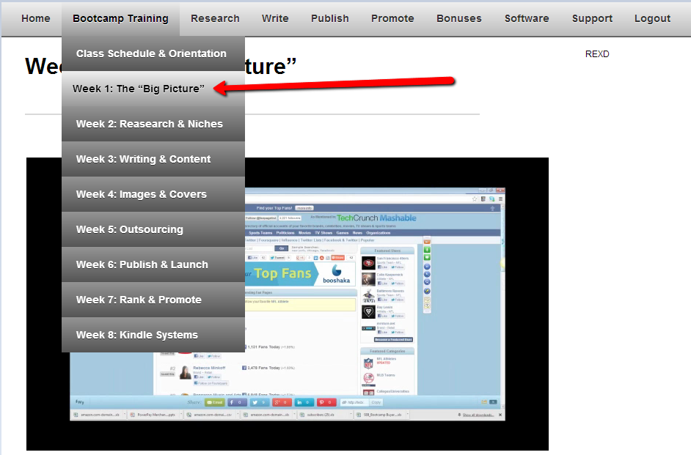

______________________ Enter Date Completed

- Join the Apex Authors Facebook group.
https://www.facebook.com/groups/apexauthors/

______________________ Enter Date Completed

- Watch “Niche Research Training” videos

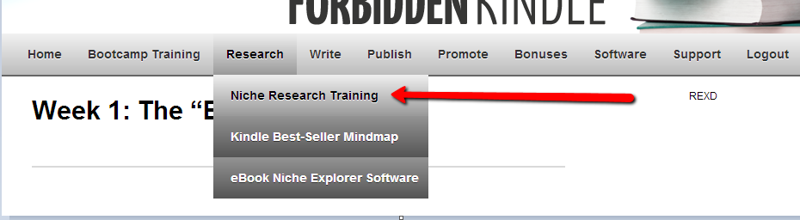

______________________ Enter Date Completed

- Download and Install eBook Niche Explorer software.

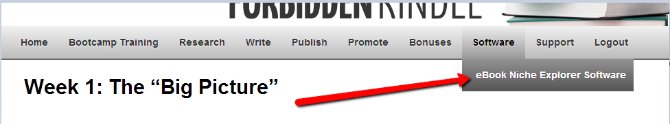

______________________ Enter Date Completed

- Find 20 niches using eBook Niche Explorer with the following criteria:

- At least $3,000 Total Monthly Gross Sales
- A ‘Green’ or ‘Yellow’ Designation

You can use suggestions from the Research Mindmap or come up with your own. The research Mindmap is available in the member’s area.

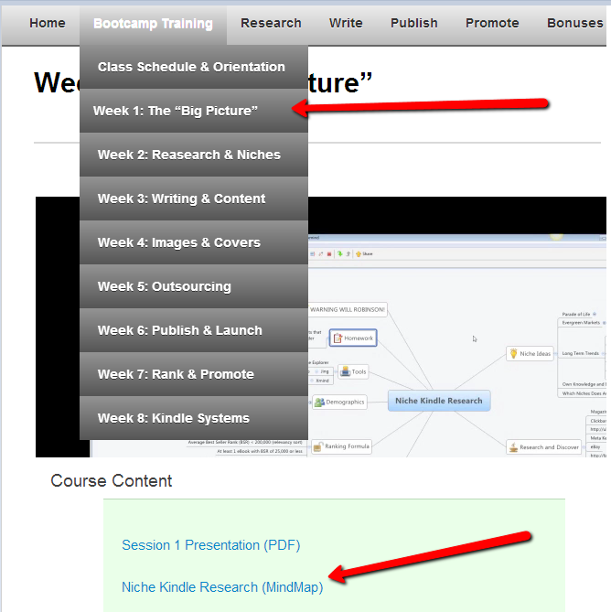

Export these niches to a new folder on your computer called “Kindle
Niches.” Create a text new file for each niche. You may also want to take a screenshot of the niche from eBook Niche Explorer and paste it into this workbook so you have everything in one place.

______________________ Enter Date Completed

Optional Homework

- If you already have an eBook published, find the 5 highest-grossing
Keyword phrases related to your eBook.

1 _______________________________________________

2 _______________________________________________

3 _______________________________________________

4 _______________________________________________

5_______________________________________________

What did you find? Is this a good niche? Are there any “money”
Keyword phrases that you’d like to rank your book for?

- Submit your questions for inclusion in Thursday night’s Q & A “Hotseat Session.” Submit to lookin2013vip@gmail.com

- Submit your eBook for inclusion in Thursday night’s Hotseat Session. Submit to lookin2013vip@gmail.com

NOTES

