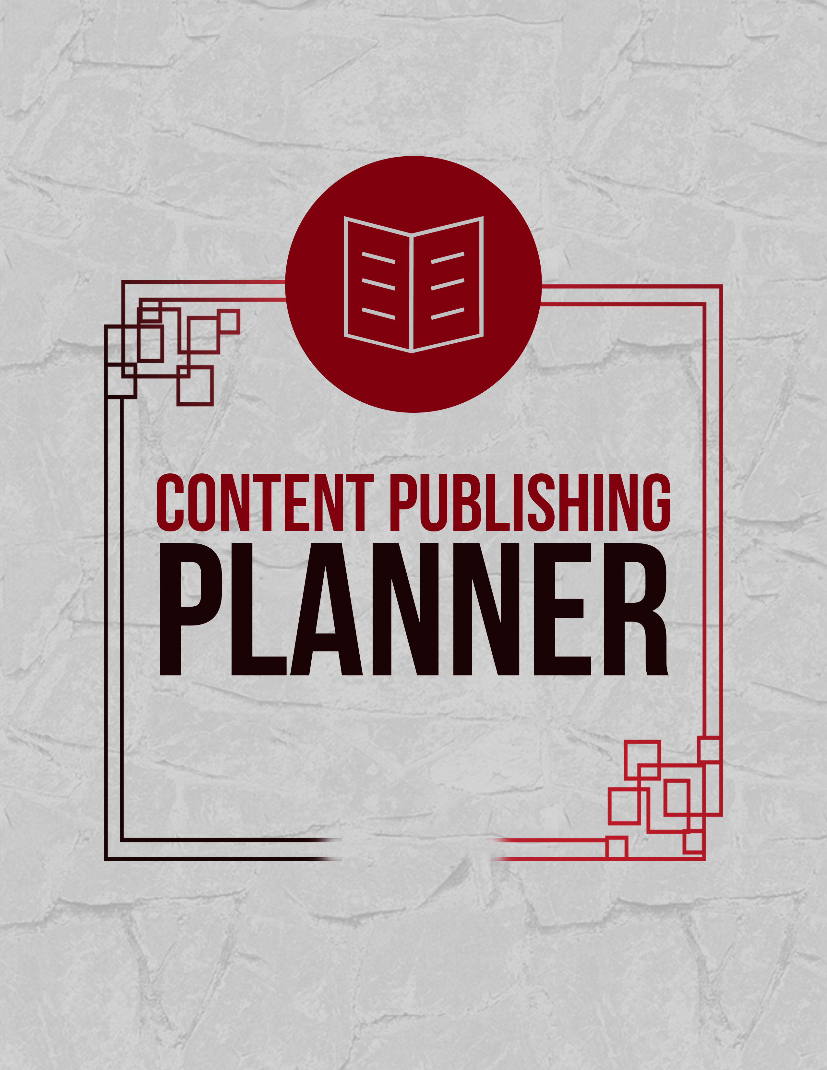

CONTENT PUBLISHING PLANNER
COVER PAGE

Content marketing has been around for ages because it works well. Fresh content gives a business an influx of new traffic shortly after publishing. If it's quality piece of content, it will continue to serve the business well for years to come.
For content to produce quality results, it has to have the following:
- A purpose or goal you're trying to reach with it
- A compelling headline that make people click to read more
- Quality visuals (images, infographics, videos, etc.)
- A hook that encourages viewers to keep reading
- Valuable information written in a clear and concise manner
- A clear call to action
Places to find content ideas and inspiration
The first place you should be looking for inspiration and ideas is within your own niche. Check your competition, follow industry leaders, keep up on research and statistics being posted about your topic(s). Watch your audience to see what they're talking about, asking, need and want.
You can also find inspiration on places like the Twitter Business Blog which posts a monthly calendar with ideas. There are a bunch of online resources such as Almighty.press that help identify trending topics. If you're looking for something a bit different, you might find it at Forekast. Then, you have the older trusty sources like Quora and Yahoo Answers. You can also find inspiration from places like YouTube and other social media sites, as well as industry specific and general business magazines.
Curating content can save you a ton of time. It can bring great value to your readers as well. While the bulk of your content should be original, if you choose to use curated content, you can find a large list of content curation sources here.
The following pages will help you plan your content publishing schedule for approximately one to two weeks.

Content Publishing Planner

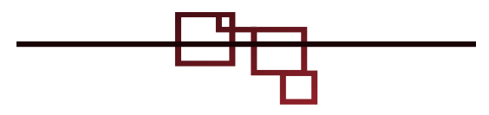
Blog Post & Long-Form Article

Title: ________________________________________________________
Purpose: _____________________________________________________
Call to action: _________________________________________________
Date to publish: ________________________________________________

Title: ________________________________________________________
Purpose: _____________________________________________________
Call to action: _________________________________________________
Date to publish: ________________________________________________

Title: ________________________________________________________
Purpose: _____________________________________________________
Call to action: _________________________________________________
Date to publish: ________________________________________________

Title: ________________________________________________________
Purpose: _____________________________________________________
Call to action: _________________________________________________
Date to publish: ________________________________________________

Title: ________________________________________________________
Purpose: _____________________________________________________
Call to action: _________________________________________________
Date to publish: ________________________________________________

Title: ________________________________________________________
Purpose: _____________________________________________________
Call to action: _________________________________________________
Date to publish: ________________________________________________

Case Study, eBook, Checklist & Report

Title: ________________________________________________________
Purpose: _____________________________________________________
Points to include:
__________________ __________________ __________________
__________________ __________________ __________________

Call to action: _________________________________________________

Title: ________________________________________________________
Purpose: _____________________________________________________
Points to include:
__________________ __________________ __________________
__________________ __________________ __________________

Call to action: _________________________________________________

Video & Presentation

Title: ________________________________________________________
Purpose: _____________________________________________________
Call to action: _________________________________________________
Channel (YouTube, Facebook, etc.): ________________________________

Title: ________________________________________________________
Purpose: _____________________________________________________
Call to action: _________________________________________________
Channel (YouTube, Facebook, etc.): ________________________________

Image & Infographic
Image 1
What type of image will it be:
- Product photo
- Non-Visual Content - words only (5 ways to…)
- Quote
- Infographic

  - Graph
  - List
  - History line
  - Flowchart
  - Comparison
  - Other: ___________

What will it say (short & to the point): _______________________________

Supporting information to include:
__________________ __________________ __________________
__________________ __________________ __________________

Style/Theme (grunge, retro, classic, etc.): ____________________________

Call to action: __________________________________________________

Channel (Pinterest, Facebook, etc.): ________________________________

Examples for reference:
______________________________________________________________
______________________________________________________________
Image 2
What type of image will it be:
- Product photo
- Non-Visual Content - words only (5 ways to…)
- Quote
- Infographic

  - Graph
  - List
  - History line
  - Flowchart
  - Comparison
  - Other: ___________

What will it say (short & to the point): _______________________________

Supporting information to include:
__________________ __________________ __________________
__________________ __________________ __________________

Style/Theme (grunge, retro, classic, etc.): ____________________________

Call to action: __________________________________________________

Channel (Pinterest, Facebook, etc.): ________________________________

Examples for reference:
______________________________________________________________
______________________________________________________________
Image 3
What type of image will it be:
- Product photo
- Non-Visual Content - words only (5 ways to…)
- Quote
- Infographic

  - Graph
  - List
  - History line
  - Flowchart
  - Comparison
  - Other: ___________

What will it say (short & to the point): _______________________________

Supporting information to include:
__________________ __________________ __________________
__________________ __________________ __________________

Style/Theme (grunge, retro, classic, etc.): ____________________________
Call to action: __________________________________________________

Channel (Pinterest, Facebook, etc.): ________________________________

Examples for reference:
______________________________________________________________
______________________________________________________________
Image 4
What type of image will it be:
- Product photo
- Non-Visual Content - words only (5 ways to…)
- Quote
- Infographic

  - Graph
  - List
  - History line
  - Flowchart
  - Comparison
  - Other: ___________

What will it say (short & to the point): _______________________________

Supporting information to include:
__________________ __________________ __________________
__________________ __________________ __________________

Style/Theme (grunge, retro, classic, etc.): ____________________________

Call to action: __________________________________________________

Channel (Pinterest, Facebook, etc.): ________________________________

Examples for reference:
______________________________________________________________
______________________________________________________________

Curated Content

Title: ________________________________________________________
Source: ______________________________________________________
Purpose: _____________________________________________________
Call to action: _________________________________________________
Publish location(s): _____________________________________________

Title: ________________________________________________________
Source: ______________________________________________________
Purpose: _____________________________________________________
Call to action: _________________________________________________
Publish location(s): _____________________________________________

Title: ________________________________________________________
Source: ______________________________________________________
Purpose: _____________________________________________________
Call to action: _________________________________________________
Publish location(s): _____________________________________________

Title: ________________________________________________________
Source: ______________________________________________________
Purpose: _____________________________________________________
Call to action: _________________________________________________
Publish location(s): _____________________________________________

Title: ________________________________________________________
Source: ______________________________________________________
Purpose: _____________________________________________________
Call to action: _________________________________________________
Publish location(s): _____________________________________________

Title: ________________________________________________________
Source: ______________________________________________________
Purpose: _____________________________________________________
Call to action: _________________________________________________
Publish location(s): _____________________________________________

